Graduated Undergraduate Honor Theses Students
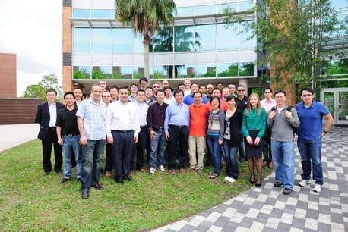
- Ross A. Kerley, Fall 2011
Small-Scale Hybrid Alternative Energy Maximizer for Wind Turbines and Photovoltaic Panels

- Jonathan Baker, Summer 2009
An Optimal, Low-Cost Design for Small Wind Turbine Converters Applied to Charging Batteries

- Christopher Hamilton, Summer 2009
Digital Control Algorithms: Low Power Wind Turbine Energy Maximizer for Charging Lead Acid Batteries

- Roberto Miguez, Spring 2009
Introduction to the Grand Solar Belt of America: Combinatorial Optimization Using Genetic Algorithms

- Venceslav Gaydarzhiev, Fall 2007
Energy Extraction using Maximum Energy Harvesting Control as a refinement over Maximum Power Point Tracking on an Energy Harvesting Backpack.

- Najlae Yazghi, Fall 2006
Interactive Learning System for Electrical Engineering Circuits

- Justin Reese, Fall 2006
Averaged Model of a Three-Port Solar Power Converter

- Matt Hicks, Spring 2006
High Frequency DC-DC converters

- Adje Mensah, Fall 2004
Modeling and Analysis of Solar Arrays for Grid Connected Systems with Maximum Power Tracking

- Rebecca Hayman, Fall 2004
DSP-Based Design of Solar-Based Inverter Systems

- Loni Gibson, Fall 2000
Steady State Analysis and Simulation of an Inverter Circuit for NASA Applications

- Enrique Tenicela, Summer 2000
Steady State Analysis for a New Power Static Inverter Topology for Aerospace Applications

- Danny Tawil, Spring 1995
Analysis of PWM Converters Including Transistor and Inductor Losses

- Debra-Ann Kemnitz, Spring 1994
Simulation of Family of DC-to-DC Resonant Converters

- Henry Nguyen, Spring 1993
Steady State Analysis and Design of Parallel Resonant Converters

